Module 11 Lab:

Streaming Dynamic Content using Amazon CloudFront

____________________________________________________

COS 20019- Cloud Computing Architecture

Nguyen Manh Dung

2/6/2023

So this is all my step to complete Module 11 Lab, with detailed explanation.

**Task 1: Lab Preparation**

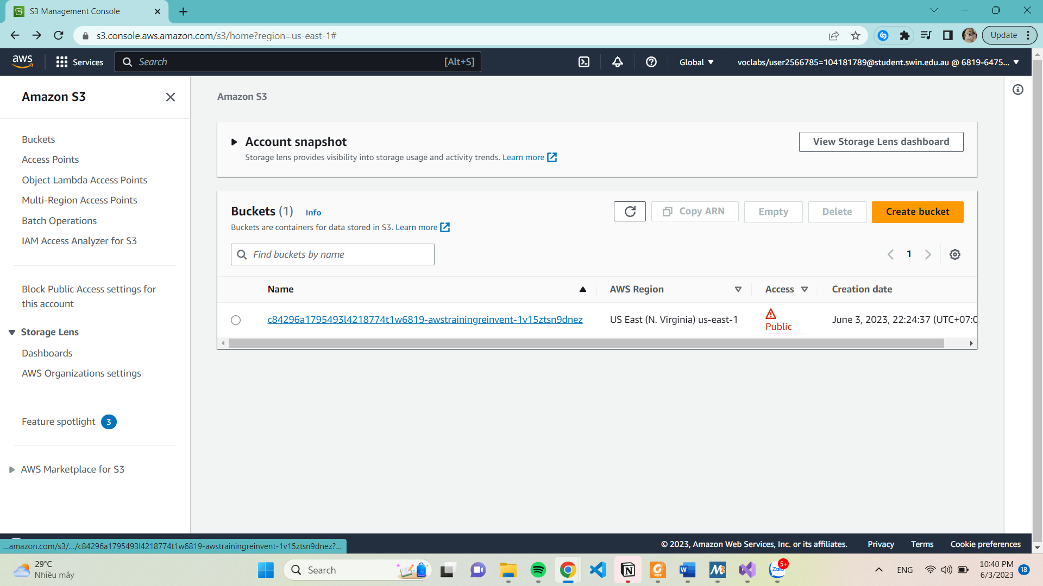

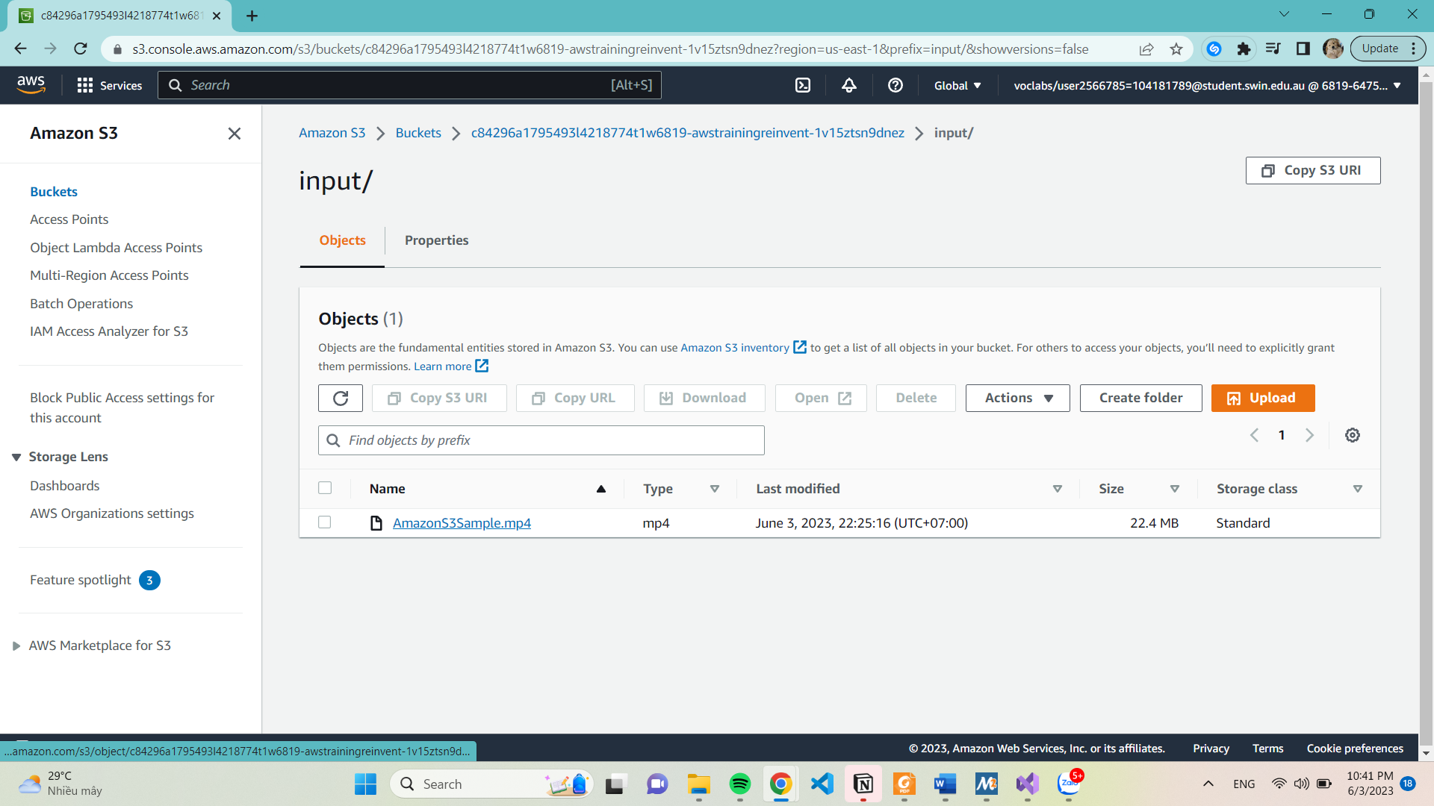

**Task 2: Create an Amazon CloudFront Distribution**

**7-10.** On the **Services** menu, choose **CloudFront.**

* Choose **Create Distribution.**
* Under the **Web** section of the page, choose **Get** **Started**.
* Under **Origin** **Settings** section of the page, enter the follow information:
* Select the **Origin** **Domain** **Name** field. A list of S3 buckets will appear. Choose the one that was created earlier that has **awstrainingreinvent** as part of the file name.
* Under **Restrict** **Bucket** **Access** select **No**.
* Scroll to the bottom of the page, then choose **Create** **Distribution**.

**Task 3: Create an Amazon Elastic Transcoder Pipeline**

12-20: In the AWS Management Console, on the **Services** menu, choose **Elastic** **Transcoder**.

* On the Pipelines page, choose **Create a new Pipeline**
* For **Pipeline** **Name**, enter InputPipeline
* For **Input** **Bucket**, select the awstrainingreinvent S3 bucket.
* For **IAM** **Role**, under **Other** **roles**, select **AmazonElasticTranscoderRole**.
* In the **Configuration for Amazon S3 Bucket for Transcoded Files** and Playlists section:
* Under **Bucket**, select the **awstrainingreinvent** S3 bucket.
* Under **Storage** **Class**, select **Standard**.
* In the **Configuration** **for** **Amazon** **S3** **Bucket** **for** **Thumbnails** section, enter the following information:
* Under **Bucket**, select the **awstrainingreinvent** S3 bucket.
* Under **Storage** **Class**, select **ReducedRedundancy**.
* Choose **Create** **Pipeline**.

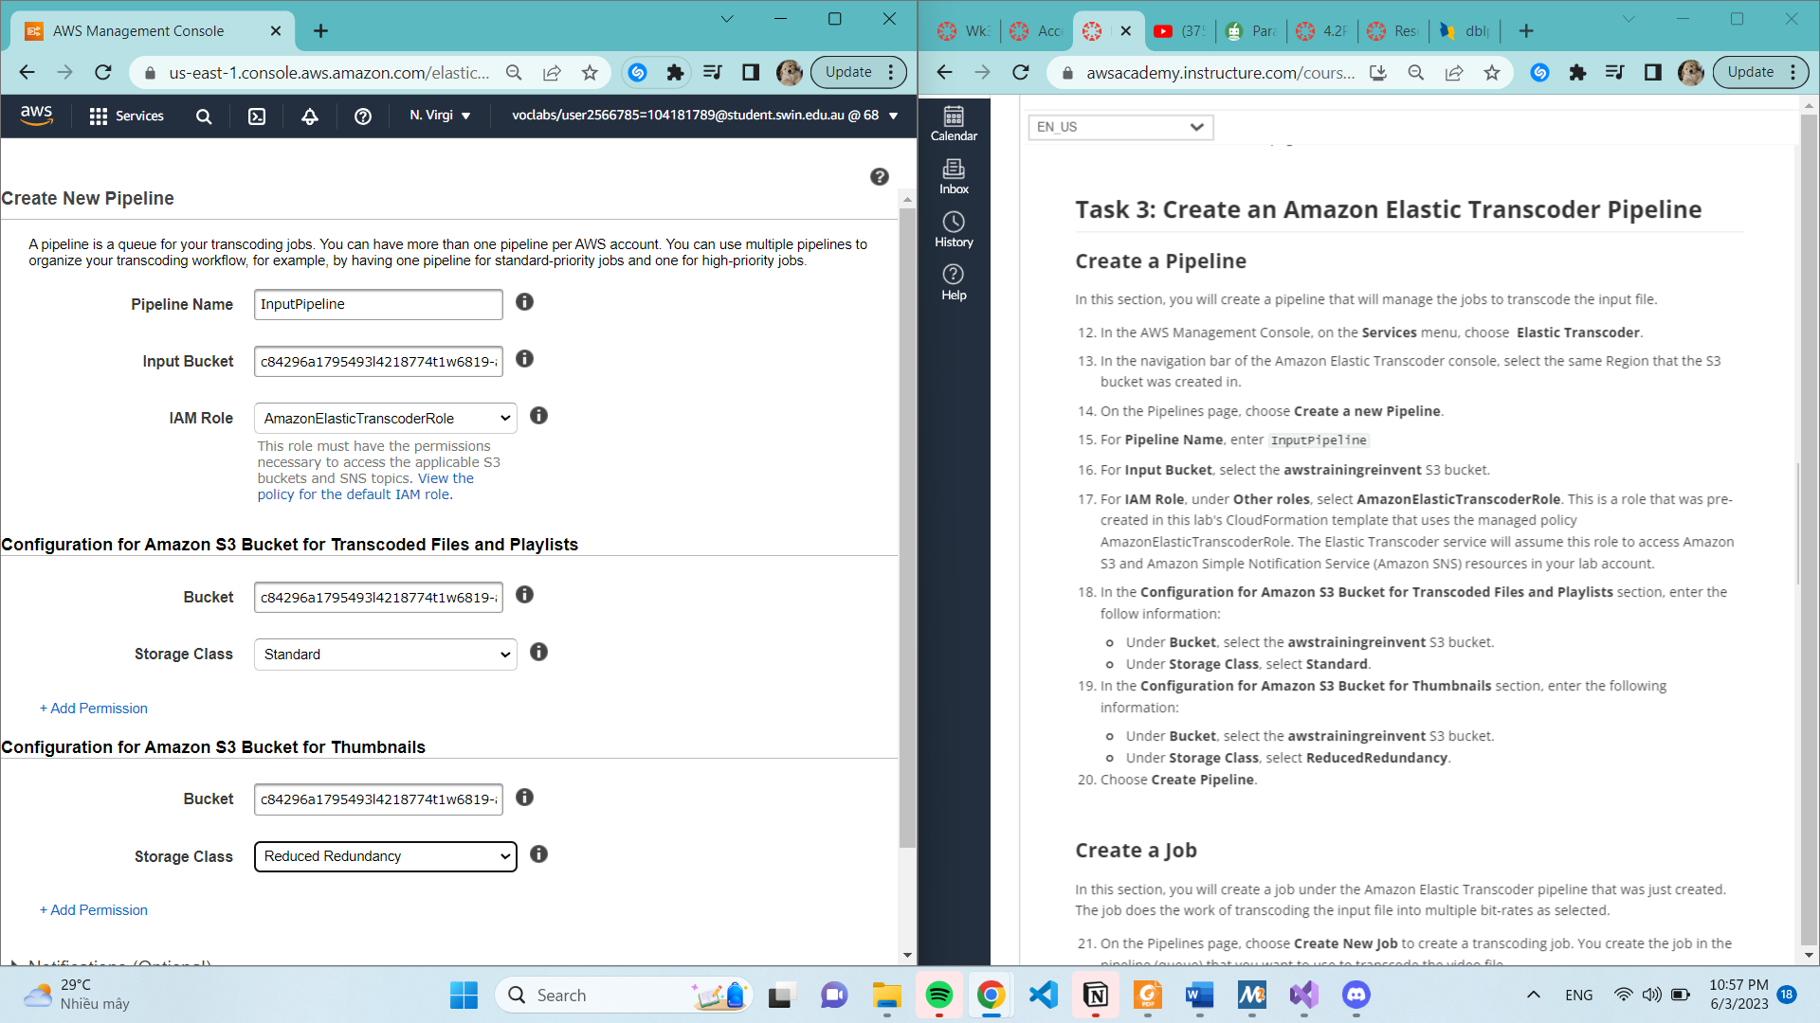

**Create Job**

**22.** For **Pipeline,** select **InputPipeline.**

**23.** For **Output Key Prefix**, enter output/.

24. For **Input Key,** select the input file labeled **input/AmazonS3Sample.mp4.**

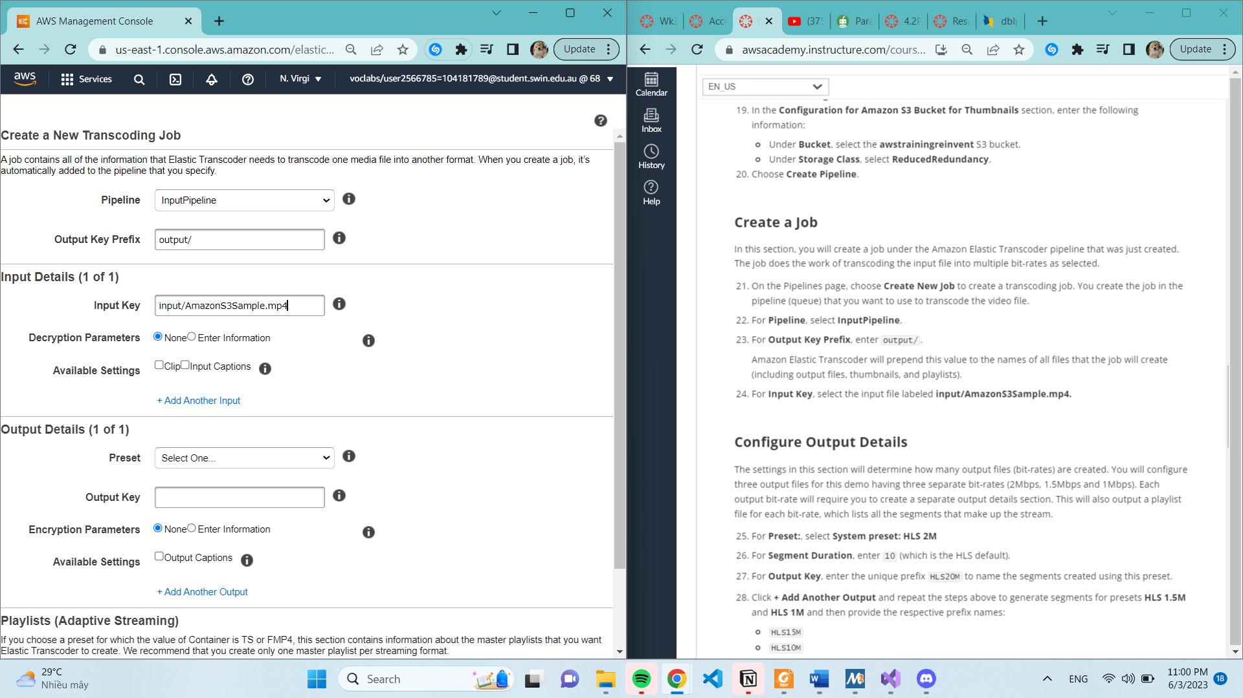

**Configured Output Detail**

**25-28.**

* For **Preset**:, select **System** **preset**: **HLS** **2M**
* For **Segment** **Duration**, enter 10 (which is the HLS default).
* For **Output** **Key**, enter the unique prefix HLS20M to name the segments created using this preset.
* Click + **Add** **Another** **Output** and repeat the steps above to generate segments for presets **HLS** **1.5M** and **HLS** **1M** and then provide the respective prefix names:
  + HLS15M
  + HLS10M

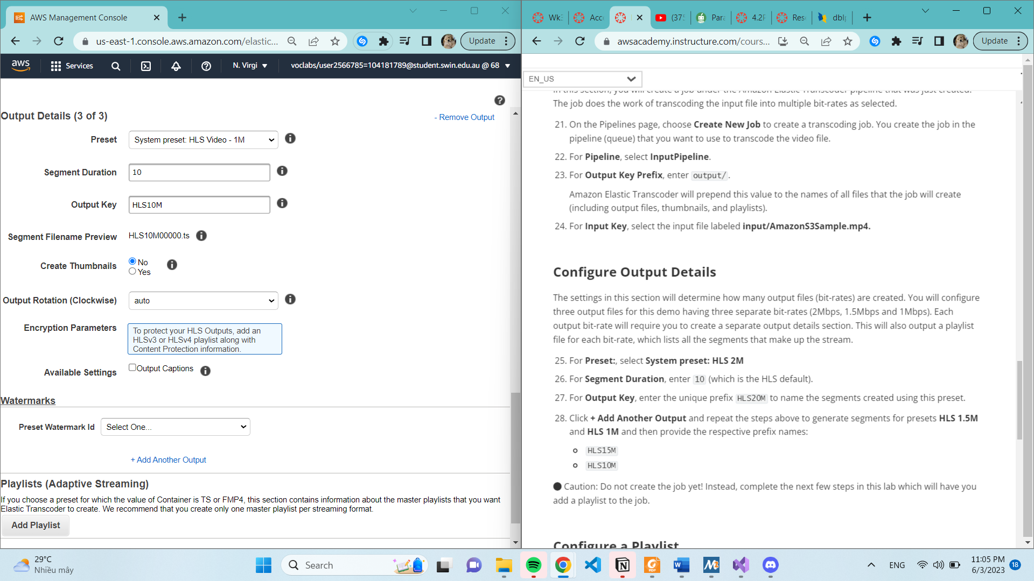

**Configure Playlist**

**29-31**

* Under **Playlists (Adaptive Streaming),** choose **Add Playlist**, then configure:
  + **Playlist Name** primary
  + **Playlist Format:** HLSv3
* Choose **Create New Job.**

**Task 4: Test Playback of the Dynamic (Multi Bit-Rate) Stream**

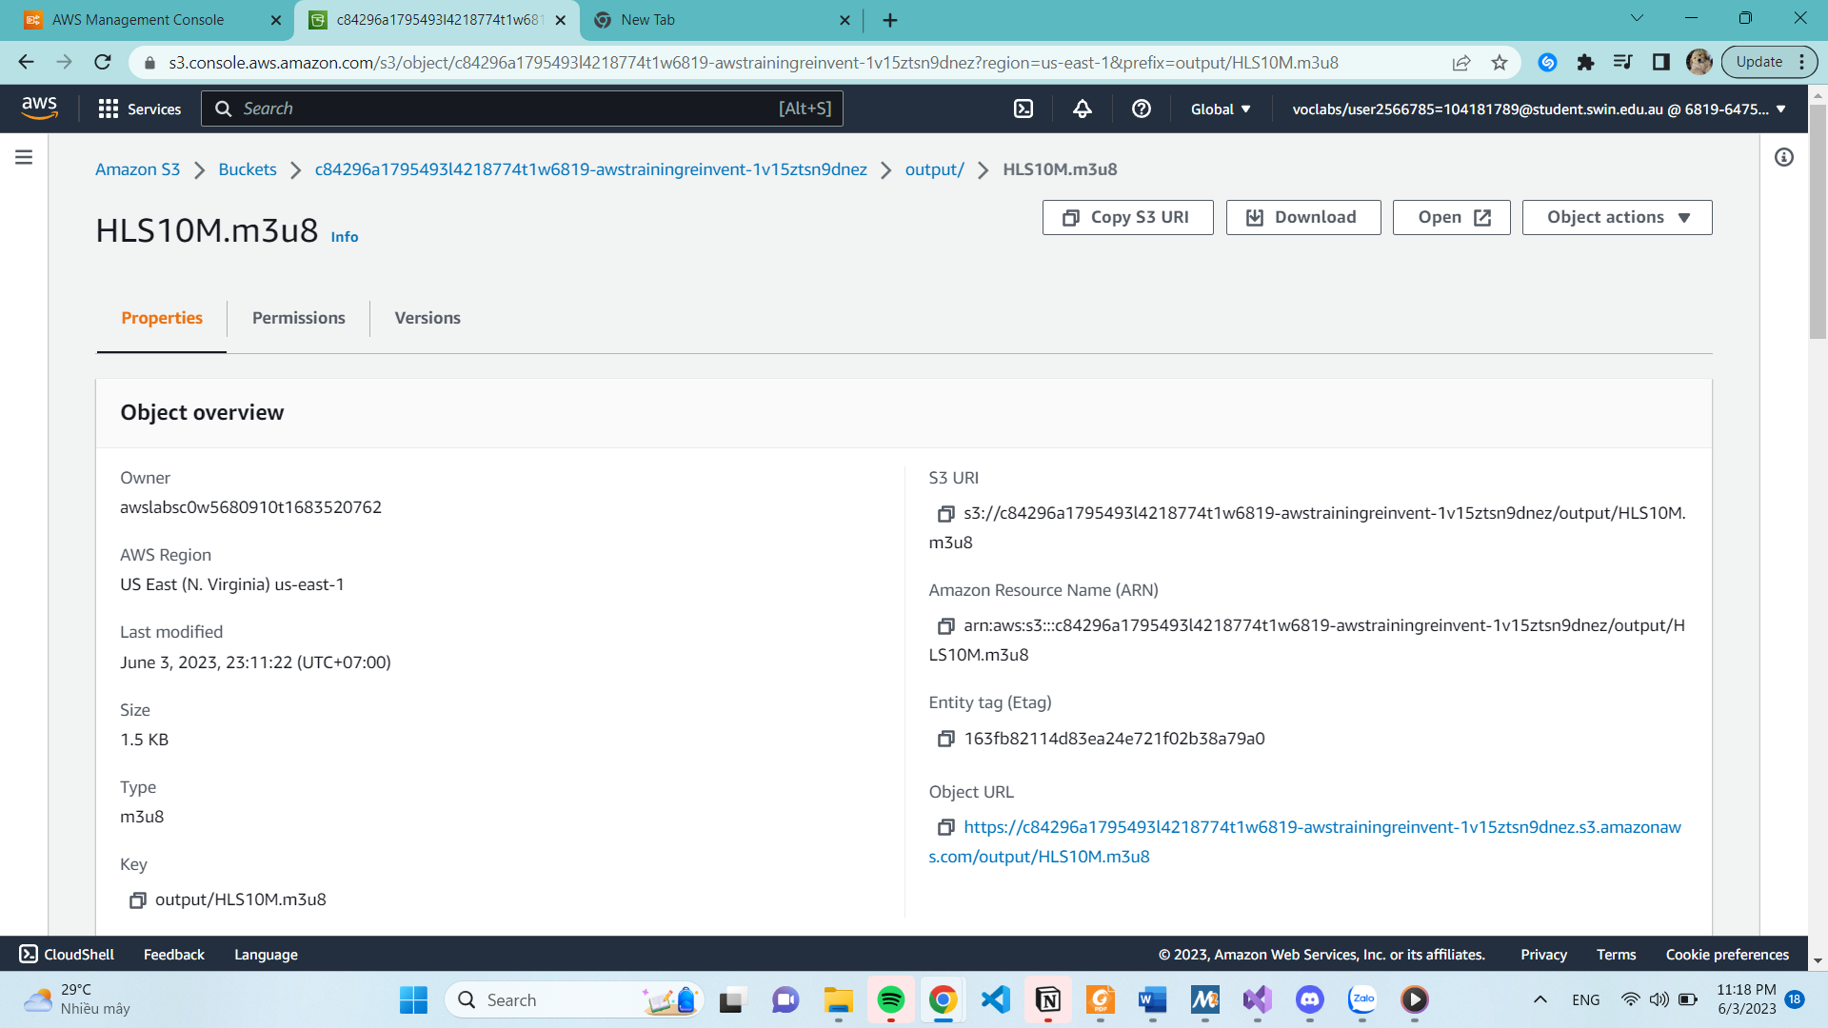

https://d3gm7o6zr1nk13.cloudfront.net/output/primary.m3u8